Ex.N.3: Spectrum Analysis of Sub-1 GHz, Mid-band & mmWave by Plotting Propagation Loss.
AIM:
To analyze the propagation loss characteristics of different frequency bands (Sub-1 GHz, Midband, and mmWave) in wireless communication systems and compare their performance over varying distances using MATLAB.
OBJECTIVE 1:
To compute the Propagation Loss (dB) for Sub-1 GHz, Mid-band, and mmWave frequency ranges using standard path loss models.

Matlab Code and Output:
clc; clear; close all;

d = 0.1:0.1:5; % Distance (km)
f = [900 3500 28000]; % Frequency (MHz)

PL1 = 32.44 + 20*log10(f(1)) + 20*log10(d);
PL2 = 32.44 + 20*log10(f(2)) + 20*log10(d);
PL3 = 32.44 + 20*log10(f(3)) + 20*log10(d);

figure

% -------- Graph 1 -------- subplot(2,1,1) plot(d,PL1,'b','LineWidth',2); hold on plot(d,PL2,'r','LineWidth',2) plot(d,PL3,'k','LineWidth',2) title('Propagation Loss vs Distance') xlabel('Distance (km)') ylabel('Loss (dB)') grid on

% -------- Graph 2 (NO legend used to avoid error) ------ subplot(2,1,2)
Freq = [900 3500 28000];
Loss = [PL1(10) PL2(10) PL3(10)];

plot(Freq,Loss,'-o','LineWidth',2) title('Propagation Loss vs Frequency') xlabel('Frequency (MHz)') ylabel('Loss (dB)') gridon

OUTPUT:

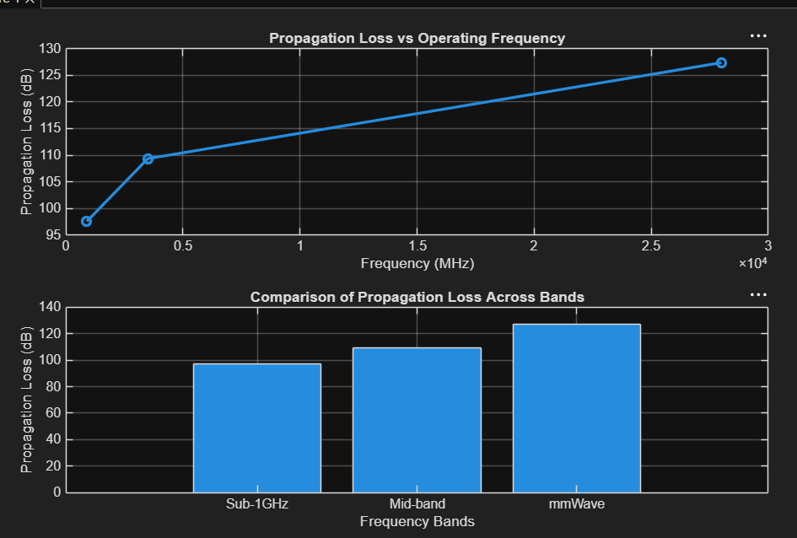

OBJECTIVE 2:
To evaluate the impact of different Operating Frequencies (GHz) on signal attenuation and coverage performance.
\
Matlab Code and Output:
clc; clear; close all;

d = 0.1:0.1:5; % Distance (km)
f = [900 3500 28000]; % Frequency (MHz)

PL1 = 32.44 + 20*log10(f(1)) + 20*log10(d);
PL2 = 32.44 + 20*log10(f(2)) + 20*log10(d);
PL3 = 32.44 + 20*log10(f(3)) + 20*log10(d);

figure

% -------- Graph 1 -------- subplot(2,1,1) plot(d,PL1,'b','LineWidth',2); hold on plot(d,PL2,'r','LineWidth',2) plot(d,PL3,'k','LineWidth',2) title('Propagation Loss vs Distance') xlabel('Distance (km)') ylabel('Loss (dB)') grid on

% -------- Graph 2 (NO legend used to avoid error) -------- subplot(2,1,2)
Freq = [900 3500 28000];
Loss = [PL1(10) PL2(10) PL3(10)];

plot(Freq,Loss,'-o','LineWidth',2) title('Propagation Loss vs Frequency') xlabel('Frequency (MHz)') ylabel('Loss (dB)') grid on
OUTPUT: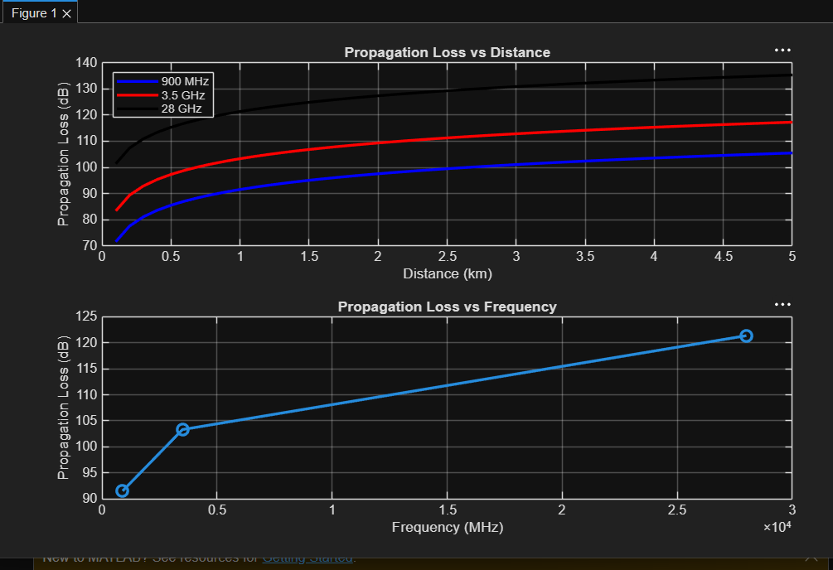

OBJECTIVE 3:
To analyze how Communication Distance (km) affects propagation loss across different spectrum bands.
Matlab Code and Output:
clc; clear; close all;

% Frequency bands (MHz)
f = [900 3500 28000];

% Distance (km)
d = 2;

% Propagation Loss (FSPL)
PL = 32.44 + 20*log10(f) + 20*log10(d);

figure

% -------- Graph 1: Simple Line Plot (SAFE) -------- subplot(2,1,1)
plot(f, PL, '-o', 'LineWidth', 2) title('Propagation Loss vs Operating Frequency') xlabel('Frequency (MHz)') ylabel('Propagation Loss (dB)') grid on

% -------- Graph 2: Safe Comparison Plot -------- subplot(2,1,2)
plot(1:3, PL, '-s', 'LineWidth', 2)
title('Band-wise Propagation Loss Comparison') xlabel('Band Index (1=Sub1GHz, 2=Mid-band, 3=mmWave)') ylabel('Propagation Loss (dB)') grid on
